How to Update the Image Slider

This article can be used to provide a step by step instructions on how to add / modify or remove images from the slider, how to change the characteristics, and where to locate the documentation. The image slider is a free plugin. Paid subscriptions are available for access to a Slider Builder.

Image Slider Source

The image slider is a responsive jQuery content slider, sourced from bxSlider created Steven Wanderski a Chicago Web Developer. This slider is free to use as used in this website. The Manual Installation method was used as documented in the Install Section of the developer’s website.

bxSlider – bxSlider.com

The jquery.bxslider files are saved in the following folders:

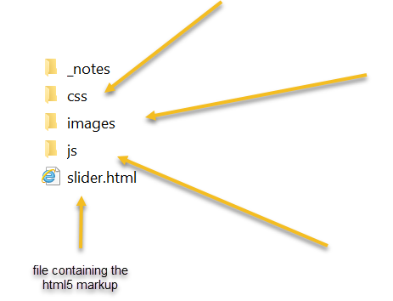
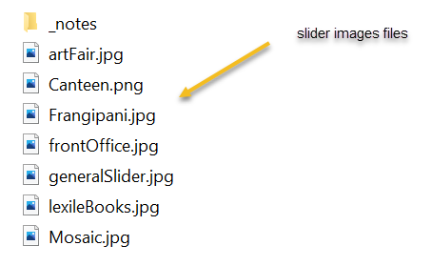
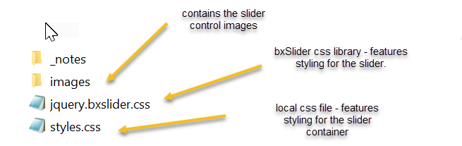

Preparing Images

Image Types: The slider can accept .PNG, .JPG and .GIF files. The preference is .JPG as they can be compressed down to a smaller size. The .PNG format can be used where transparency is required or for logos and .GIF format when animation is desired.

Image Size: 1000px by 300px at 72 dots per inch (dpi). It is important to try to keep the aspect ratio (10:3) of the slider container. The settings of the slider will scale the image to fit the area if the image is not exact. Be aware that cropping will occur if the aspect ratio is not maintained.

Using the photo editor of your choice save the image in the images folder with a brief, meaningful name. If the image name is two words then use camel case naming convention. e.g. artFair.jpg See above diagram for examples.

Adding images to the image slider

To add a new image to the image slider carousel, follow these steps

- Open the html file called slider.htm located in the root directory.

- Once open insert the following line of code substituting the details of the image you are inserting. Place the line of code in the position you want the image to appear in the slider carousel. For example, if you want the slider to be the first image, then insert the code at the start.

- Save the changes and upload the file to the website.

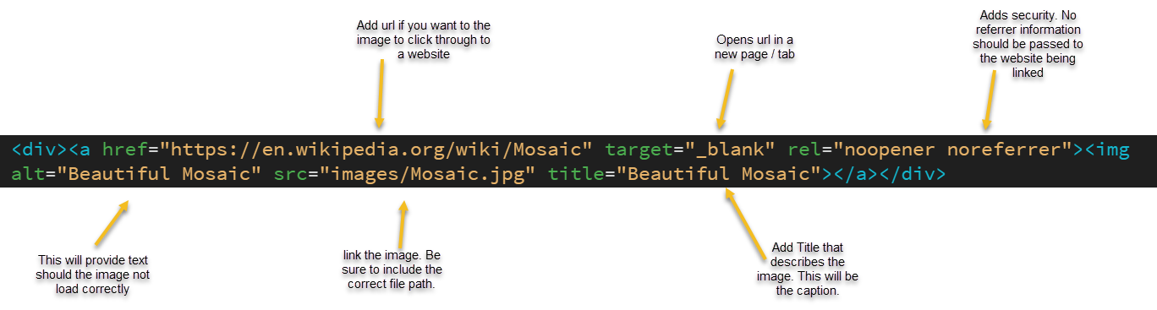

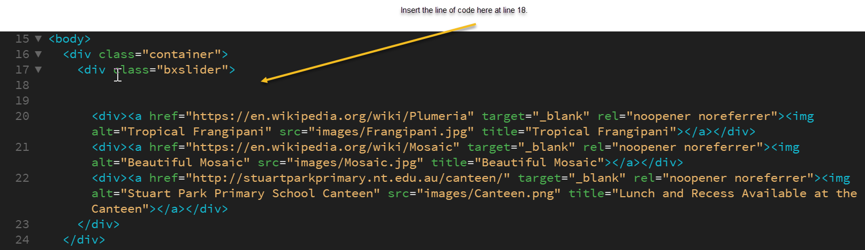

Deleting images from the image slider

- To delete an image. Open the file slider.htm. Highlight the whole line of code relating to the image and press delete.

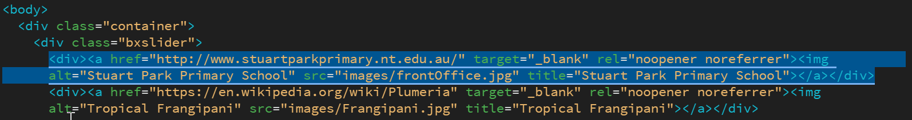
- Save the changes and upload the file to the website.

Modifying the image slide

To modify the slider, review the documentation located bxslider.com - options or follow the link to Github where you will find more information and feedback from the developer and other users. Stack Overflow is also a good resource. The following code is located in the JS file myScript.js. This sets how the slider will function. There are a range of options for this slider that can be changed.

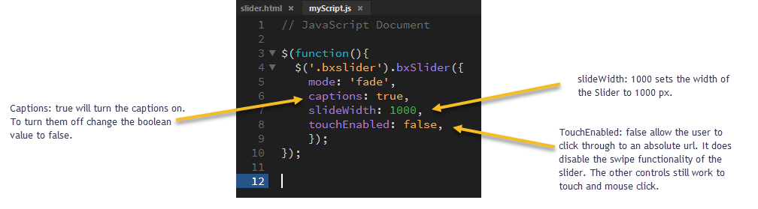

Useful Website links
bxslider.com
bxslider.com/options
bxslider.com/install
github.com/stevenwanderski/bxslider-4
stackoverflow.com

DOCUMENT VERSION INFORMATION
Date Approved | Version | Brief Description | Approved By
24/06/2021 | 1.0 | How to Update the Images Slider. | Ingrid Barry

